 |  | 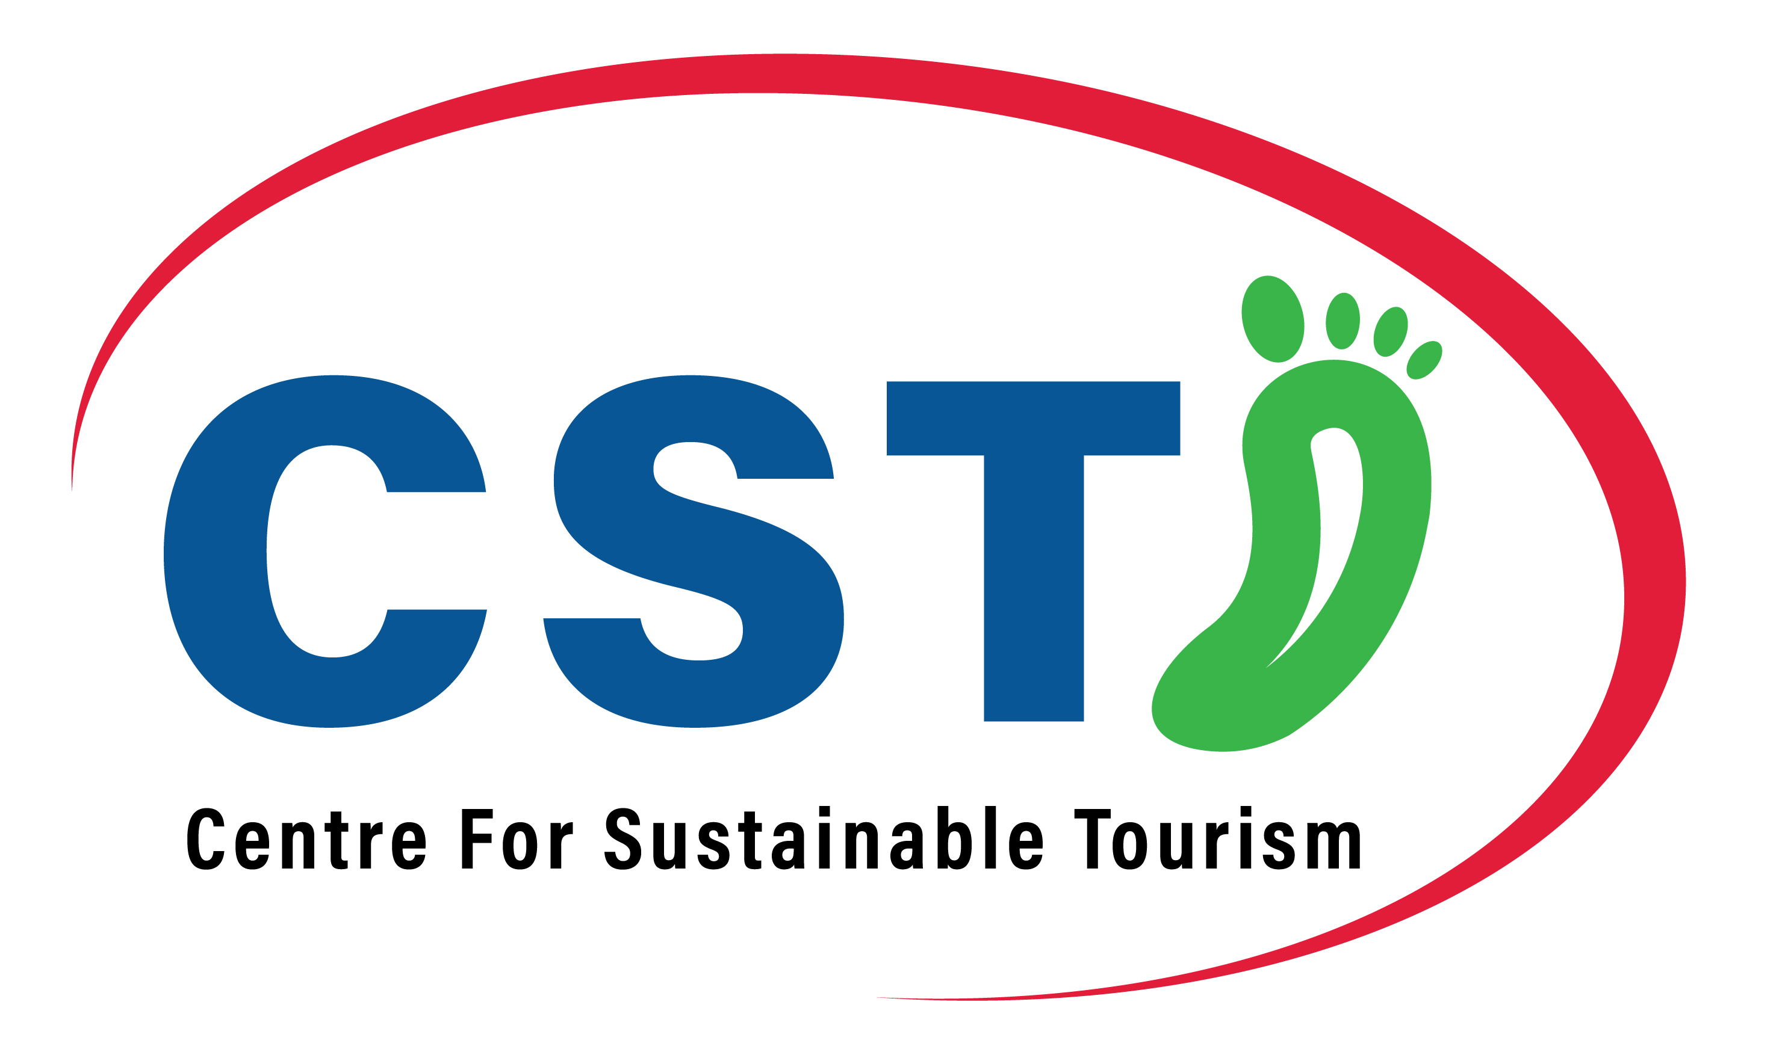 |  |  | 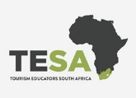
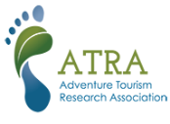
11th International Adventure Conference
‘People, place and planet – new hospitalities’
9-11 September 2024, Knysna, South Africa
www.atra.global

Abstracts of up to 600 words, or full papers of up to 7,000 words, are invited for double-blind peer review; these will form the basis for acceptance for presentations.
If you are submitting an abstract or full paper it should clearly state the objective of the presentation, the findings and their significance to the proceedings, and how they help advance our knowledge of outdoor adventure.
An abstract should include a title, keywords, introduction, method, findings/discussion and conclusions.
Full papers should also include a suitable literature review and abstract.
Please use Calibri font size 11 and save the document in Microsoft Word format using the family and first name of the presenter (eg. Taylor, Steve). If supplying references, please include a maximum of five.
Inspiring conference posters are also requested from postgraduate students.

Paper title
Keywords
Format of presentation
Sub-theme
Author(s)
Affiliation
Email of the corresponding author
Co-writing partner needed
Abstract

