7th International Adventure Conference
17th – 21st June 2019 Dumfries & Galloway, Scotland, UK
CALL FOR ABSTRACTS

The 2019 International Adventure Conference
We are delighted to invite you to the region of Dumfries and Galloway in south west Scotland, home to the UK's first Dark Sky Park in the UK and offering some of the darkest skies in Europe. The combination of hills, coast, lochs and forest makes it a first class destination for those who enjoy nature and outdoor activities.
It is the same natural appeal which has attracted world-class events including the Tour of Britain, the RAC Rally and the World Gold Panning Championships. We are looking forward to welcome our colleagues from across the globe to come together to discuss the latest research and practices pertaining to adventure tourism, in what is a very accessible and unspoilt part of Scotland but what is form many unexplored.
The seventh International Adventure Conference will follow our previous events in Scotland, Norway, England, Ireland and Spain, which have attracted a truly worldwide audience - from a range of different specialisms, and with participants from 30+ countries in attendance over the years.
​We look forward to welcoming you to the 2019 conference, to experience one of Scotland's many hidden gems, breathe the fresh sea air and feel the peace of the hills and forests of Galloway, as well as exploring the many castles and historic buildings in the local towns of Gatehouse of Fleet, the artist town of Kirkcudbright, the historic Isle of Whithorn, the food town of Castle Douglas and Dumfries, the resting place of Scotland's national poet Robert Burns.

Conference Theme
In the stunning setting around Segovia in Spain, delegates earlier this year considered the variety of atmospheres, conditions and climates that enable and constrain our activities outdoors. However, in parallel with these discussions, the 17 Sustainable Development Goals (SDGs) were agreed by the United Nations. These challenging ideals and targets go way beyond environmental concerns framed in the narrow vision of pristine protected wildernesses. Importantly the goals now emphasise human interaction with the planet, with nature and with each other, using the ‘three Ps: poverty, planet and prosperity.
Our delegates - from a range of different climates - carry with them stories related to all of the seventeen SDGs. Our 7th International Adventure conference will therefore open up critical discourses about these powerful new goals – economic, social, cultural, philosophical and physical.
We aim to bring together leading academics and industry practitioners in the fabulous setting of Dumfries and Galloway in Scotland, to learn about and to debate burning issues in nature-based and adventure tourism, outdoor recreation and outdoor learning. Of course, as this year, themes such as journeys, liminality, boundary crossing and escape attempts from home are also core and related concepts, but should for 2019 reflect the concepts of the sustainable development goals (clickable for more information).
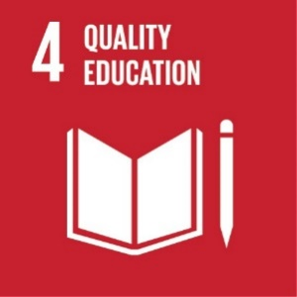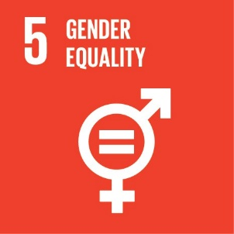
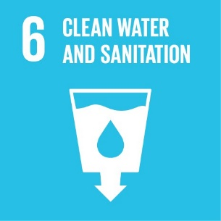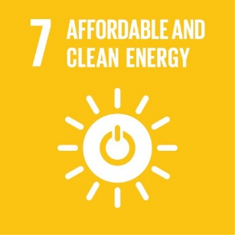
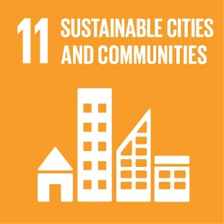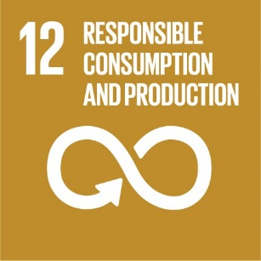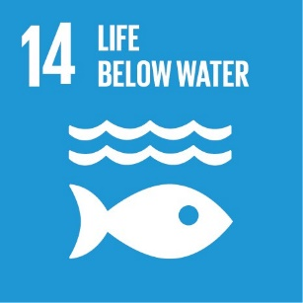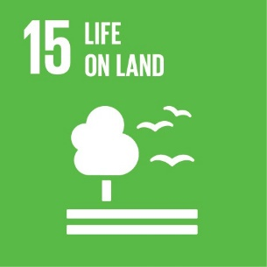
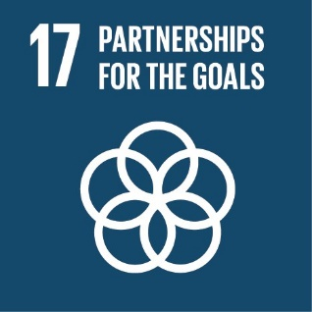

Conference Rates
The following conference rates will apply:
- Academics full attendance (early bird rate before 31st January 2019): £350
- Academics full attendance (standard rate): £400
- Students: £225 (limited to first 20 students)
- Practitioners: £225
Academic and student rates include a year’s membership of ATRA.
Conference booking will open on November 1st 2018.
Submission of Abstracts and Posters
In the first instance, abstracts of up to 600 words are invited for peer review; these will form the basis for acceptance of the paper for presentation. The abstract should therefore clearly state the objective of the presentation, the findings and their significance to the proceedings, and how they help advance our knowledge of outdoor adventure. Please submit your abstract highlighting the particular SDG (or more than one) which your work addresses. It should also include: title, keywords, introduction, method, findings/discussion and conclusion.
Exciting and inspiring conference posters are also requested from postgraduate students.
Please note: all abstracts should be submitted to jfarkic@gmail.com, using the template provided.
The deadline for the submission of abstracts is 30th September 2018.
Note: All accepted abstracts will be published in the conference book of abstracts, and will be available on the conference web page. There is also the possibility for some papers to be considered for post-conference publication in a suitable format.

The Adventure Tourism Research Association
The conference fee includes a year’s membership of the Adventure Tourism Research Association (ATRA), a membership organisation which is assembling a worldwide academic community, and helping to facilitate knowledge exchange and the creation of new relationships in the field of outdoor leisure and adventure tourism.
ATRA works with local partners to host the annual international adventure conference. The association’s website, www.atra.global, is a shared portal for ATRA members’ news.

Local Hosts
The conference is being organised in collaboration with the University of the West of Scotland and Laggan Outdoor.
UWS undertakes career-focused teaching, world-leading research with an international outlook equipping students with an innovative outlook and ambition. UWS has four campuses across Scotland including Dumfries. The University offers undergraduate degree course in Tourism Management and Sports Coaching and Development. These faculties along with tourism and event management students are supporting the organisation of IAC 2019.
Laggan Outdoor is an award-winning activity centre set on the stunning Solway Coast. In 2007, Duncan diversified part of the family farm to create the facilities which have developed in 10 years into an extensive centre which offers adventure activities for individuals, families and corporate groups of all ages and abilities.
The Centre has continued to develop and boasts Europe’s longest zip wire spanning 820 metres. November 2017 saw the opening GG’s Yard, a purpose-built event space, the venue for IAC 2019 (https://ggsyard.co.uk/).

Further Information
If you would like to learn more, please contact Jelena Farkic (ATRA) at jfarkic@gmail.com regarding abstract submission or 2019iac@gmail.com for event information.

